Metabolism Matters

Your metabolism - combined with your daily physical activity - determines how many calories
your body burns each day.

Until recently, there was no convenient or affordable way to measure your metabolism. Now, with the
BodyGem® device, you can easily and quickly learn your metabolic rate with a simple breath test that
your health professional can administer in 10 minutes or less.

Why would I want my metabolism measured?
A metabolic measurement will determine how many calories your body needs to meet your goals.

Specifically, a MedGem or BodyGem measurement might be right for you if you are:
- Trying to lose weight
- Trying to maintain weight (after a weight management program or other nutritional changes)
- Diagnosed with diabetes, sleep apnea, high blood pressure, or other weight-related conditions
- Interested in improving overall health and fitness

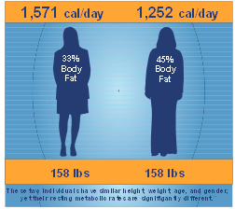
Why is my metabolism unique?
Many factors influence your metabolism, making it unique to you:
- Weight
- Age
- Body Composition (the ratio of muscle vs. fat)
- Hormone Levels
- Gender

In this example, two women weigh exactly the same and are the
same height, yet have very different daily calorie requirements.
If they followed the same weight management plan, they would experience very different results.

Why do metabolism-based programs work?
An accurate daily calorie target provides the single best piece of information available to lose weight.
It allows you to set an achievable goal to keep you motivated and focused.

Your metabolism determines how much you need to eat and exercise to reach your goals.
You can customize any plan to be more effective when it is based on your body’s unique characteristics.

Your metabolism changes as you lose weight. Re-measurement during weight loss allows you to avoid weight loss plateaus by altering your nutrition and exercise plan to reflect changes in your body.

To setup your metabolism measurement:
Contact

